Half Page Hand Traced Map with Directions
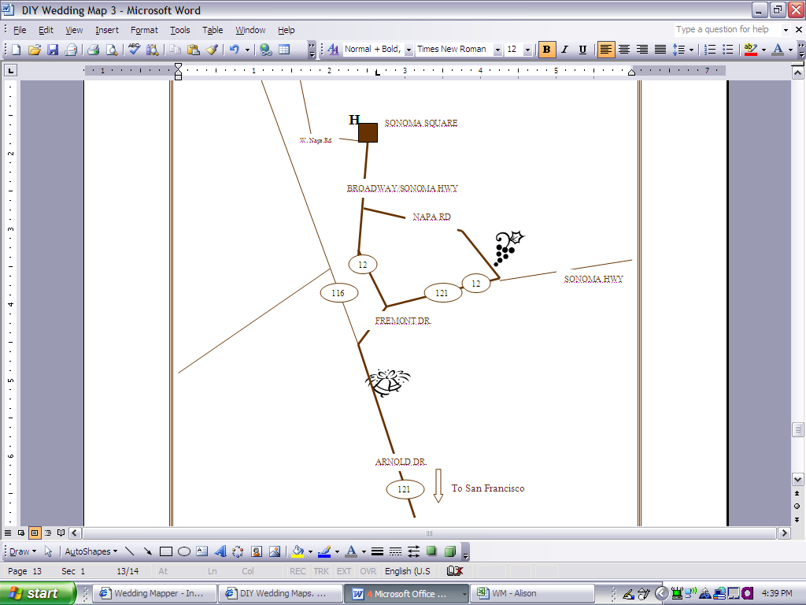
H
Hotel El Dorado
405 1st St. W
Sonoma, CA 95476

Cornerstone Gardens
23570 Arnold Dr./Hwy 121
Sonoma, CA 95476

Nicholson Ranch Winery
4160 Napa Rd
Sonoma, CA 95476
Zach G Alison

Directions
Hotel El Dorado to Nicholson Ranch Winery
- Head north on 1st St. W toward W Spain St.
- Turn left at W Spain St.
- Turn left at 2nd St. W
- Turn left at W Napa St.
- Turn right at Broadway
- Turn left at Napa Rd.

Hotel El Dorado to Cornerstone Gardens
- Head north on 1st St W toward W Spain St
- Turn left at W Spain St
- Turn left at 2nd St W
- Turn left at W Napa St
- Turn right at Broadway
- Slight right at CA-121
- Turn left to stay on CA-121

Please visit our wedding map for more local attractions, information, and directions:
www.weddingmaper.com/zachandalison2007

Half Page Hand Traced Map with Directions
Like the Hand Traced Map, this map is more challenging and time consuming because you are using traced lines to make a more "traditional" wedding map look. This map will let you showcase a small area on one side of a piece of paper/cardstock and list directions on the other side. You can adjust the paper size to meet your individual needs.

Estimated Time: 5hr – 6hr

1. Create Your Map on WeddingMapper.com

Create your wedding map on WeddingMapper.com. Add icons for your ceremony site, reception site, airports, hotels, and any other important locations.

Fun Tip - Adding your favorite restaurants, golf course, hiking trails, spas, and local attractions will let you play virtual tour guide to your guests.

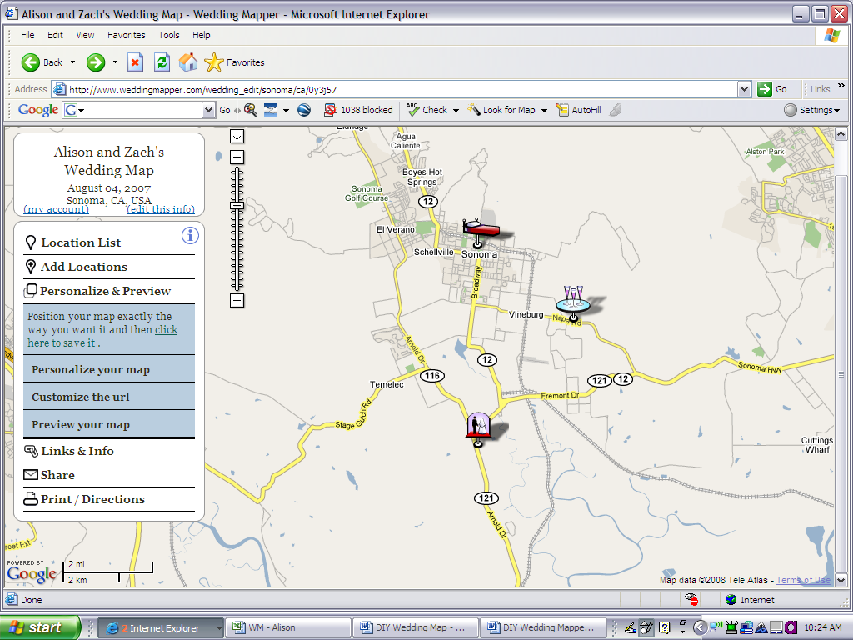

2. Set Your Wedding Map

Hide Locations –

You can hide or show locations using the location list on the left hand panel. This allows you to add local restaurants and attractions and then hide them when you are creating the map for your invitations. Click on "Location List" and click on the arrow next to the category of location(s) that you would like to hide or show.
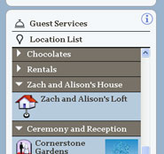

Show Location Titles –
You can display the title of each location on the map to identify things more easily. To show your location titles on your map go to "Print/Directions" and click on "Print Instructions". Then click on "Show the location titles".
You can also move the location titles by dragging them.

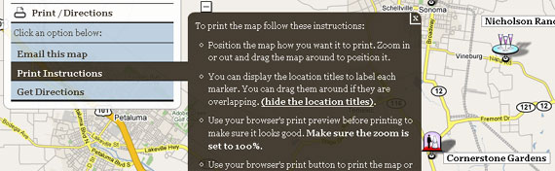

3. Copy Your Wedding Map

PC
Ok, here comes the tricky part. It's actually not hard at all, it's just a little techie.
Position your map so that it looks exactly like you want it to look in your invitations. Then hold down the "Alt" button and hit "PrtScn". This will take a snapshot of your map.
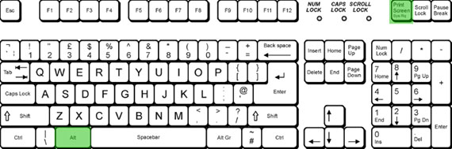

MAC
To copy your wedding map on a Mac hold down the Apple (Command) Key + Shift + 4
Your cursor will turn into a cross and you can hold down the mouse button and drag to select the part of the screen you want. Press 'Esc' to release.
When you release the button the screenshot will "snap" that part of the screen and create an image on your desktop. You can then import that image into your Wedding Map design.
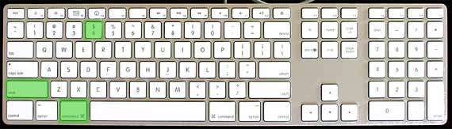

4. Paste into Microsoft Word

Create a new Word doc and set your paper size. To do this simply change the page size to the card dimensions (File, Page Setup, PAPER tab).

Paste your screenshot into the document by either hitting Ctrl + V or right clicking and selecting "Paste".

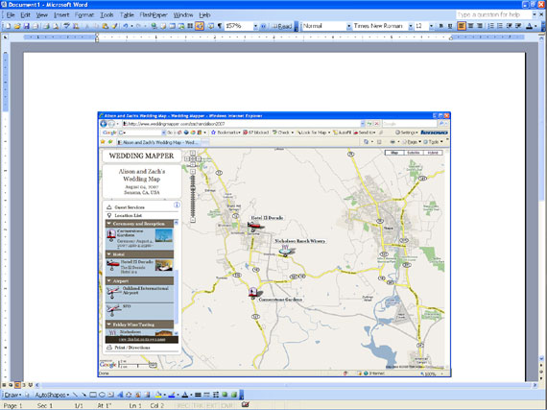

5. Crop and Enlarge Your Picture
Right click on the screenshot/map and click on "show picture toolbar". Then click on the "crop" icon in the toolbar.
Click on the box around the image and drag inward to crop the image to only show the important information. Once the image is cropped click on the "crop" icon again.
To enlarge your map click on the box around the image and drag outward.

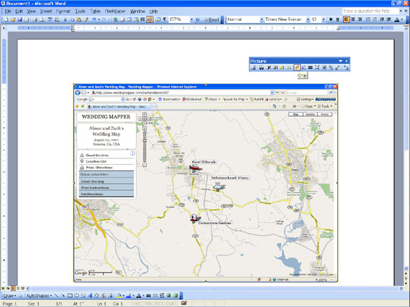

6. Trace the Roads
You can use your "Drawing" toolbar (at the bottom of the screen or click on "View", "Toolbars", "Drawing") to trace over the main streets on your map.
Click on LINE to begin.
Try using both the straight line and the CURVE (click on AutoShapes, then Lines, then Curve) line to trace over the main streets. You can also make your lines thicker or change the color by right clicking on the line, "Format AutoShape", "line style" or "weight" and "color".
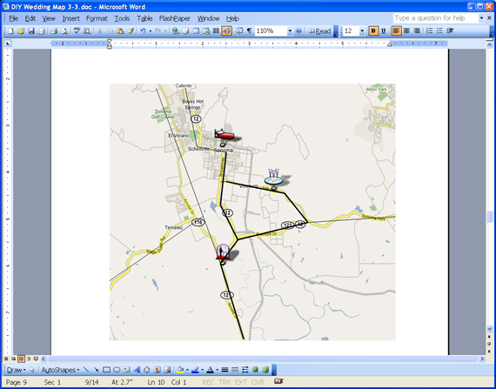

7. Remove the Map
Right click on the map and hit "cut" to erase your map.
If you don't like the way one of your lines looks or need to make a tiny change, right click on the line and click on "Edit Points".
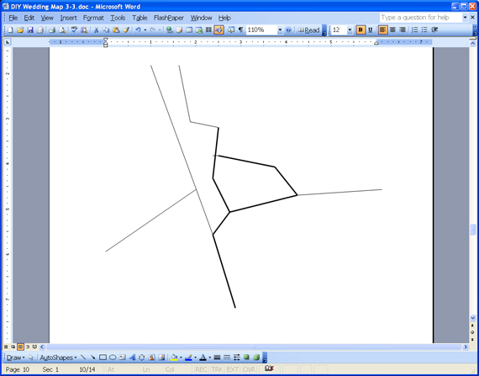

8. Add in Details
Add in shapes to label your map (Click on "Insert", "Picture", "AutoShapes").
To insert text into your shape, right click on the shape and click "Add Text". You can change the size, font, and color by highlighting the text and making the changes in the toolbar.
Show off your style by adding icons/pictures to mark your ceremony, reception, hotels, etc.
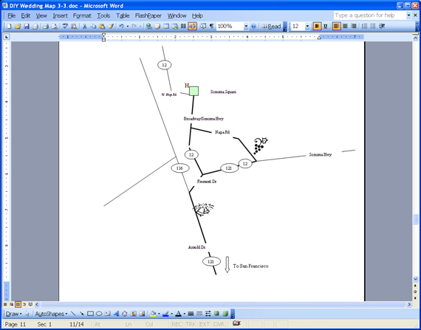

9. New Document with Custom Paper Size
Open up a new word document. To set Paper Size -go to “File”, “Page Setup”, “Paper”, and change the “Width” and Height” to the size of your paper or cardstock.

Tip – You may need to change the Orientation of your document. Go to “File”, “Page Setup”, and “Orientation” – The example is set to “Landscape”.

Tip – You may need to lower your Top and Bottom margins. Go to “File”, “Page Setup”, and “Margins”.
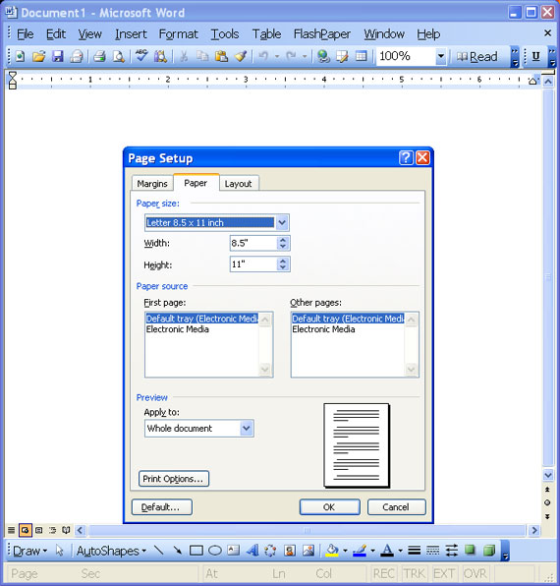

10. Copy and Paste into a New Document
Now go back to your first document and repeat steps 3 and 4 (hold down the "Alt" button and hit "PrtScn". This will take a snapshot of your map. Paste your screenshot into the document by either hitting Ctrl + V or right clicking and selecting "Paste".).
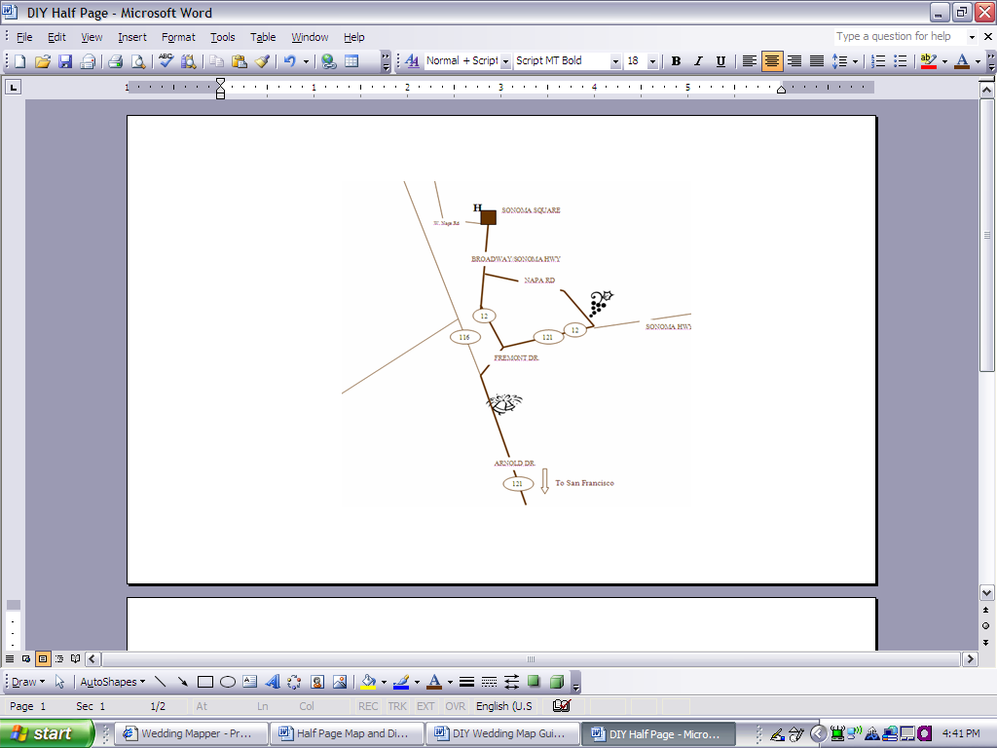

11. Finishing Touches on the Map
Add a title and addresses.
Fun Tip: Play around with fonts, borders, and colors to make your wedding map reflect the style of your wedding!
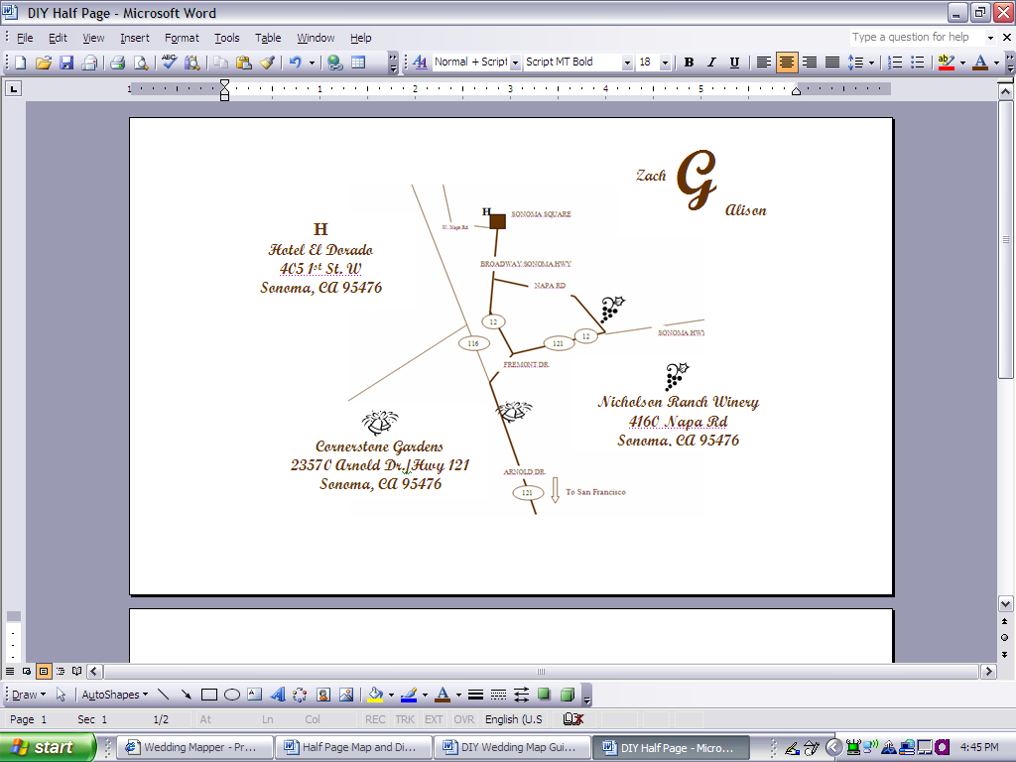

12. Directions
Go back to WeddingMapper.com and get directions from your hotel(s) to your important locations.

To get directions for your map go back to WeddingMapper.com and click on “Print/Directions”, “Get Directions”. You can get directions to or from any location on the map by selecting the location.
Simply click the location in the "Location List" or click the marker on the map.
In the bubble that pops up you can click to Get Directions "to here" or "from here".

Copy and Paste them into your document. Change the font and font color to match your map.

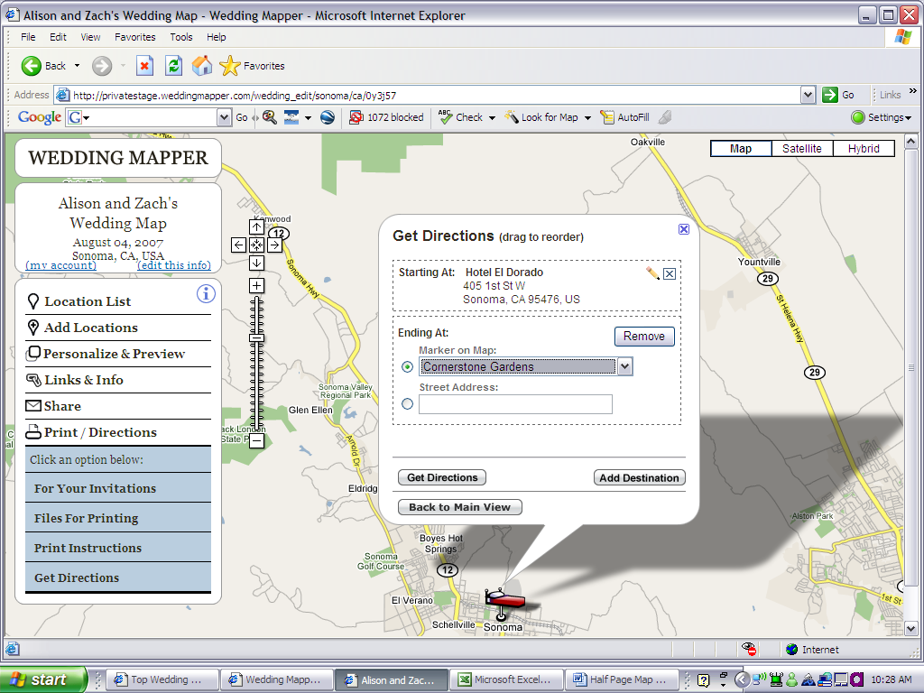

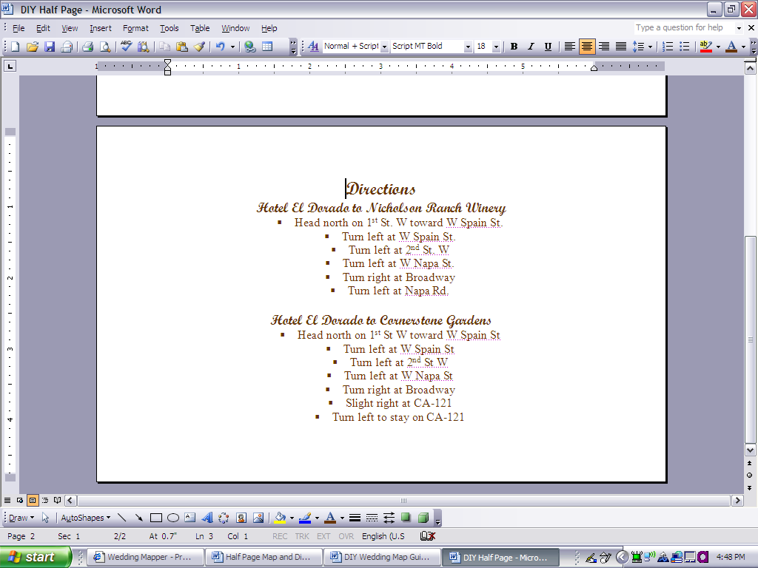

13. Nicely Done!

You have a beautifully designed map perfect for printing on cardstock.



