Hand Traced with Zoom

H
SONOMA
SQUARE

Zach and Alison
August 4, 2007
Sonoma, CA
BROADWAY/ SONOMA HWY

NAPA RD
N
12
12
121
SONOMA HWY

FREMONT

C
121

SONOMA
12
101

C
121
NOVATO
Cornerstone Gardens
80
23570 Arnold Dr.
37
VALLEJO
Sonoma, CA 95476

N
Nicholson Ranch Winery
580
4160 Napa Rd.
Sonoma, CA 95476
1

H
880
SAN FRANCISCO
Hotel El Dorado
101
OAKLAND
OAK 405 1st St. W
SFO Sonoma, CA 95476

Please visit our wedding map for more local attractions, information and directions: http://www.weddingmapper.com/zachandalison2007

Hand Traced with Zoom
This DIY map like map #2, will let you show a large area and then zoom in on a couple blocks or small town with a few important wedding locations. But, like Map #3, tracing is involved so this is time consuming and a little more complex. If you have some time and want to give guests a broader overview of the area with a "traditional" wedding map look, this is the map for you.

Estimated Time: 5hr – 6hr

1. Create Your Map on WeddingMapper.com

Create your wedding map on WeddingMapper.com. Add icons for your ceremony site, reception site, airports, hotels, and any other important locations.

Fun Tip - Adding your favorite restaurants, golf course, hiking trails, spas, and local attractions will let you play virtual tour guide to your guests.

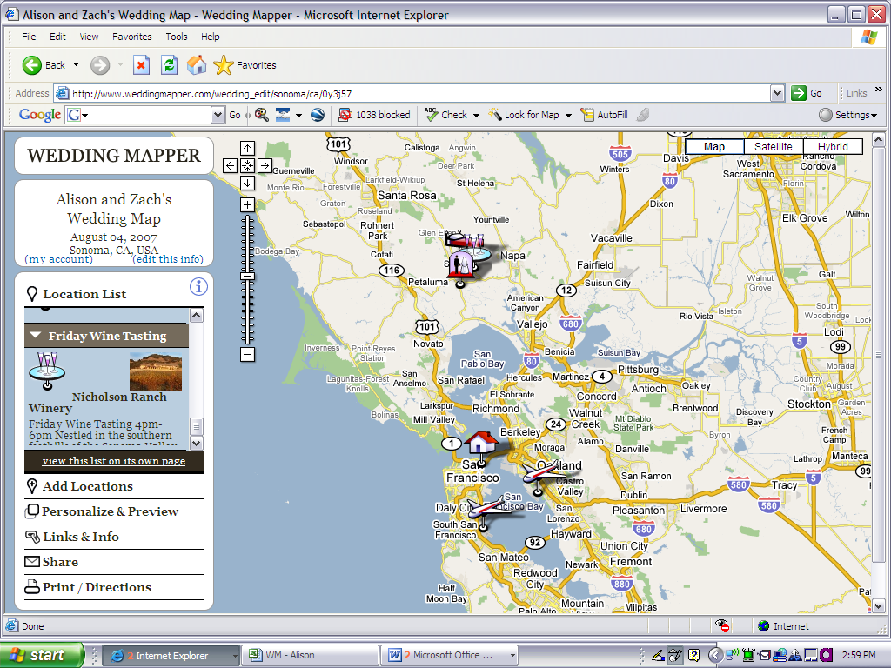

2. Set Your Wedding Map

Hide Locations –

You can hide or show locations using the location list on the left hand panel. This allows you to add local restaurants and attractions and then hide them when you are creating the map for your invitations. Click on "Location List" and click on the arrow next to the category of location(s) that you would like to hide or show.
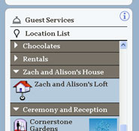

Show Location Titles –
You can display the title of each location on the map to identify things more easily. To show your location titles on your map go to "Print/Directions" and click on "Print Instructions". Then click on "Show the location titles".
You can also move the location titles by dragging them.

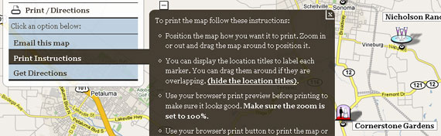

3. Copy Your Wedding Map
PC
Ok, here comes the tricky part. It's actually not hard at all, it's just a little techie.
Position your map so that it looks exactly like you want it to look in your invitations. Then hold down the "Alt" button and hit "PrtScn". This will take a snapshot of your map.
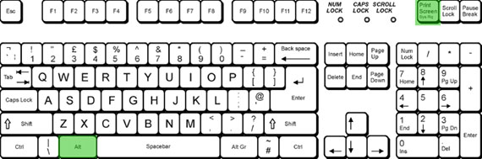

MAC
To copy your wedding map on a Mac hold down the Apple (Command) Key + Shift + 4
Your cursor will turn into a cross and you can hold down the mouse button and drag to select the part of the screen you want. Press 'Esc' to release.
When you release the button the screenshot will "snap" that part of the screen and create an image on your desktop. You can then import that image into your Wedding Map design.
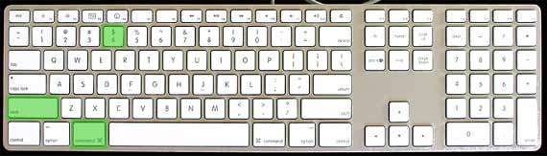

4. Paste into Microsoft Word
Create a new Word doc and set your paper size. To do this simply change the page size to the card dimensions (File, Page Setup, PAPER tab).

Paste your screenshot into the document by either hitting Ctrl + V or right clicking and selecting "Paste".

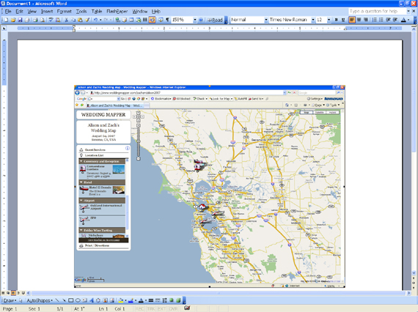

5. Crop and Enlarge Your Picture
Right click on the screenshot/map and click on "show picture toolbar". Then click on the "crop" icon in the toolbar.
Click on the box around the image and drag inward to crop the image to only show the important information. Once the image is cropped click on the "crop" icon again.
To enlarge your map click on the box around the image and drag outward.

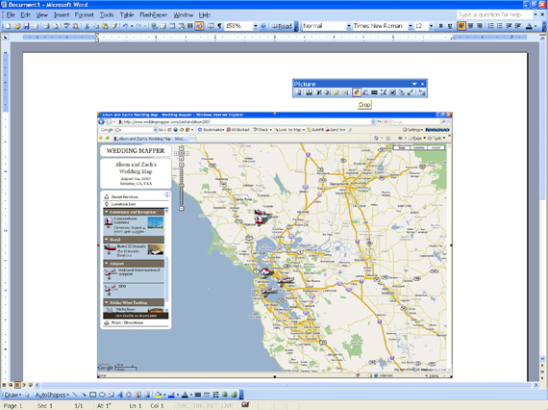

6. Create a Zoom In Area
Go back to weddingmapper.com and zoom in on a specific area. Follow steps 1-5.

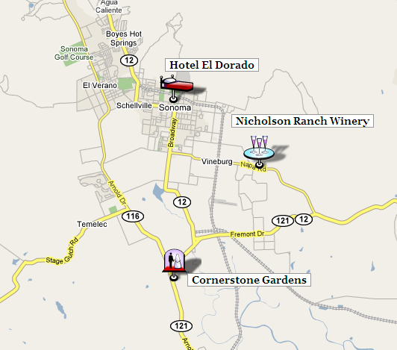

7. Position the Zoom Area
To position the first map behind the second map, right click on the first map and click on "Format Picture", "Layout", and "Behind Text". You can now move the first map behind the second map.

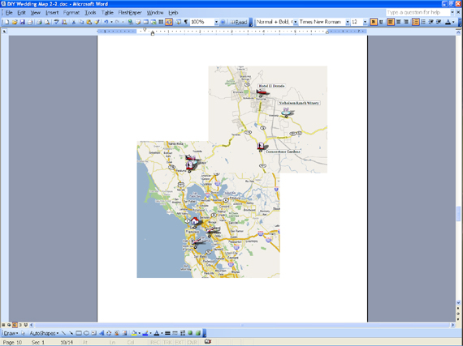

8. Create the Zoom Bubble
To add a circle around your map, go to "Insert", "Picture", and "AutoShapes".
To make your shape transparent, right click on the shape, then "Format", then "Color", and select "No Fill".
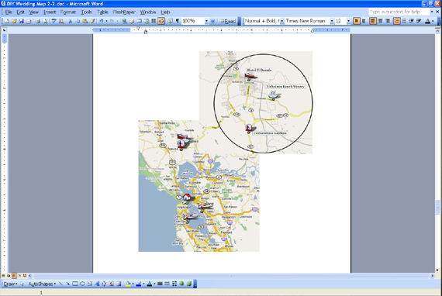

9. Connecting the Zoom Bubble
To insert a line, go to the Drawing Toolbar at the bottom of the document and click on Line. Draw a line between the first map and the second.

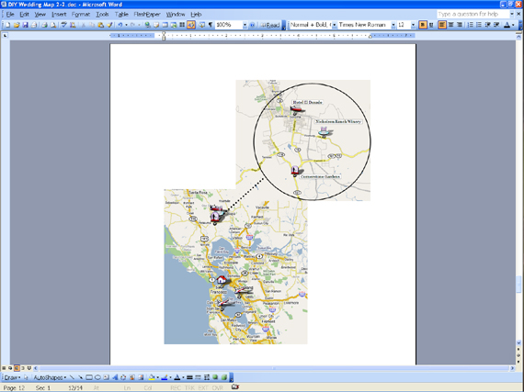

10. Trace the Roads
You can use your "Drawing" toolbar (at the bottom of the screen or click on "View", "Toolbars", "Drawing") to trace over the main streets on your map.
Click on LINE to begin.
Try using both the straight line and the CURVE (click on AutoShapes, then Lines, then Curve) line to trace over the main streets. You can also make your lines thicker or change the color by right clicking on the line, "Format AutoShape", "line style" or "weight" and "color".

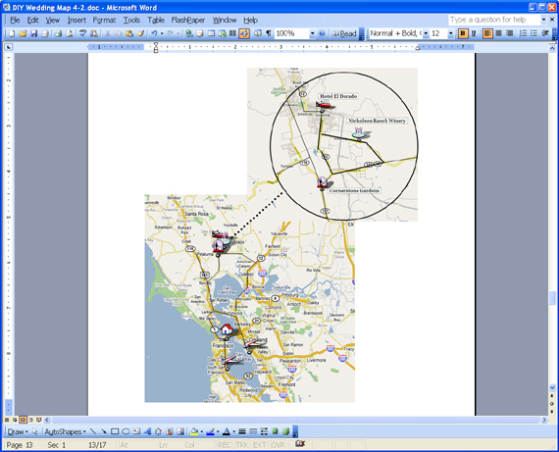

11. Remove the Map
Right click on the map and hit "cut" to erase your map.
If you don't like the way one of your lines looks or need to make a tiny change, right click on the line and click on "Edit Points".

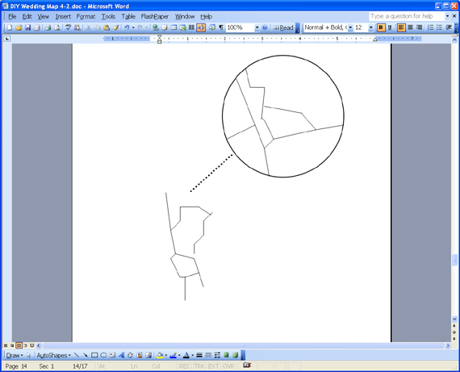

12. Add in Shapes
Add in shapes to label your map (Click on "Insert", "Picture", "AutoShapes").
To insert text into your shape, right click on the shape and click "Add Text". You can change the size, font, and color by highlighting the text and making the changes in the toolbar.
Show off your style by adding icons/pictures to mark your ceremony, reception, hotels, etc.
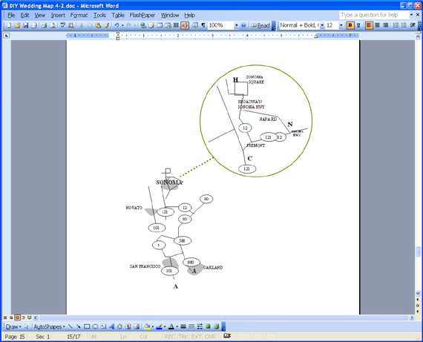

13. Finishing Touches
Add a title, border, and addresses and you're done!
Fun Tip: Play around with fonts, borders, and colors to make your wedding map reflect the style of your wedding!
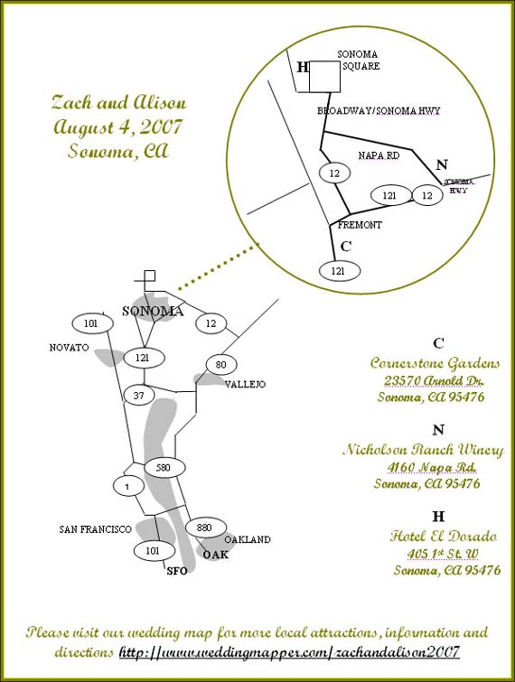
PRINT
To print your map onto cardstock or paper directly from the Word document is simple but, you should practice a couple times to make sure things are lined up correctly.
Fun Ideas-
- Print out your maps on light colored cardstock or paper. Cut out your map/information and paste it onto a different colored piece of cardstock.
- Print out your maps in color, roll, and tie with the same color ribbon as your map font/border.
- Use your maps in invitations and in hotel welcome bags.

Directions

To get directions for your map go back to WeddingMapper.com and click on “Print/Directions”, “Get Directions”. You can get directions to or from any location on the map by selecting the location.
Simply click the location in the "Location List" or click the marker on the map.
In the bubble that pops up you can click to Get Directions "to here" or "from here".

- You can print out directions on the back of your map.

- Remember to tell your guests about your wedding map on WeddingMapper.com so that they can scope out your wedding area before the wedding. They can also print out their own directions to/from your favorite locations.

