Quick and Easy with Zoom

Zach and Alison
August 4, 2007
Sonoma, CA
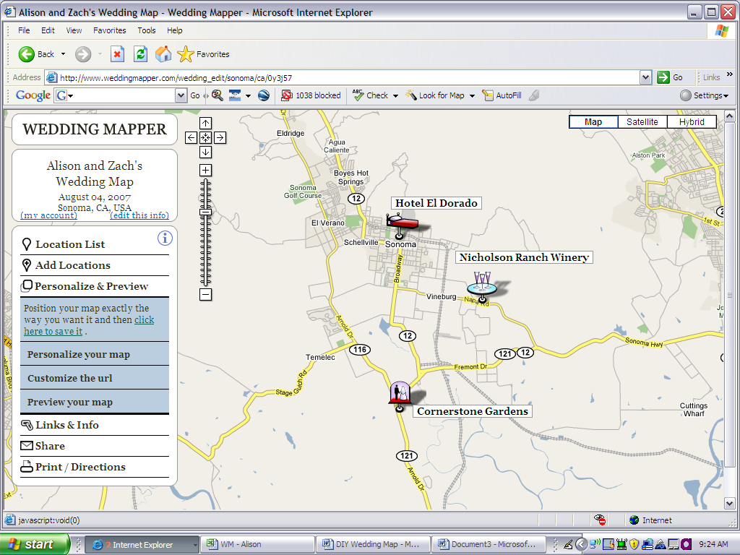

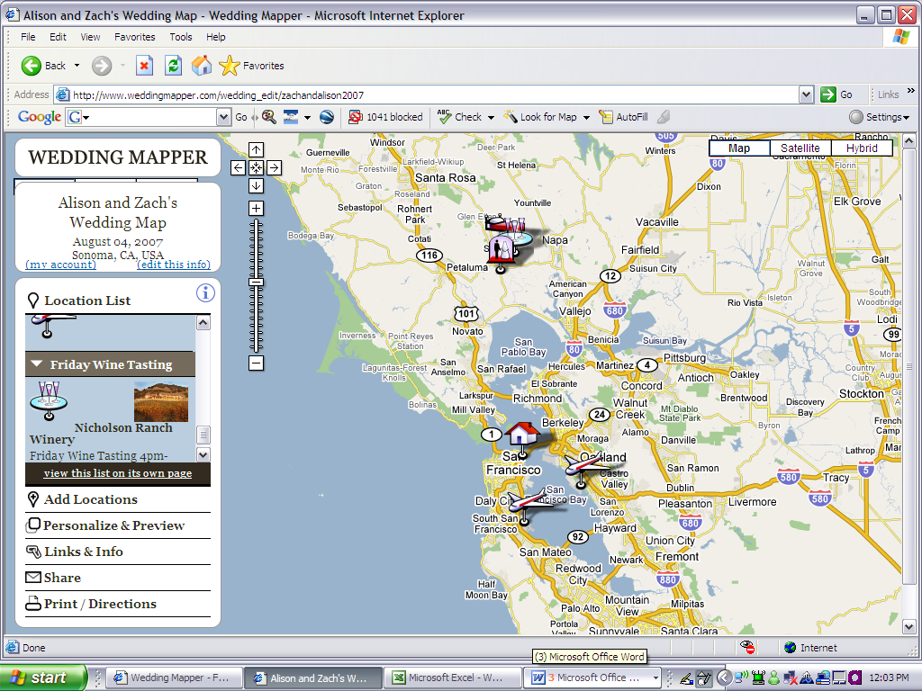

Nicholson Ranch Winery Cornerstone Gardens Hotel El Dorado
4160 Napa Rd 23570 Arnold Dr 405 1st St W
Sonoma, CA 95476 Sonoma, CA 95476 Sonoma, CA 95476

Please visit our Wedding Map for more local attractions, information and directions: www.weddingmapper.com/zachandalison2007

Quick and Easy with Zoom
This DIY map will let you show a large area and then zoom in to highlight a few key wedding locations. This map will take a little more time, but gives out of town guests a good perspective of the local area.

Estimated Time: 2.5hr – 3.5hr

1. Create Your Map on WeddingMapper.com

Create your wedding map on WeddingMapper.com. Add icons for your ceremony site, reception site, airports, hotels, and any other important locations.

Fun Tip - Adding your favorite restaurants, golf course, hiking trails, spas, and local attractions will let you play virtual tour guide to your guests.

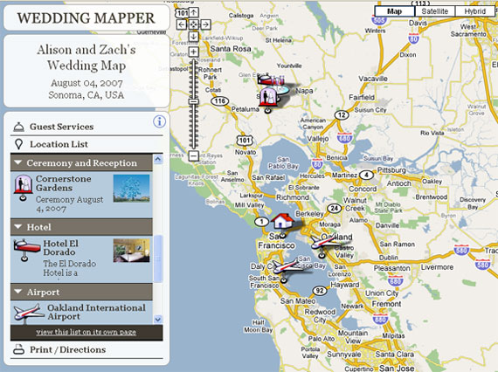

2. Set Your Wedding Map

Hide Locations –

You can hide or show locations using the location list on the left hand panel. This allows you to add local restaurants and attractions and then hide them when you are creating the map for your invitations. Click on "Location List" and click on the arrow next to the category of location(s) that you would like to hide or show.
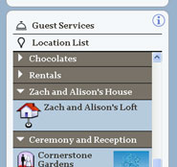

Show Location Titles –
You can display the title of each location on the map to identify things more easily. To show your location titles on your map go to "Print/Directions" and click on "Print Instructions". Then click on "Show the location titles".
You can also move the location titles by dragging them.

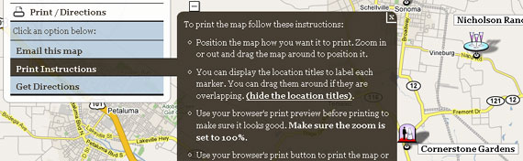

3. Copy Your Wedding Map
PC
Ok, here comes the tricky part. It's actually not hard at all, it's just a little techie.
Position your map so that it looks exactly like you want it to look in your invitations. Then hold down the "Alt" button and hit "PrtScn". This will take a snapshot of your map.
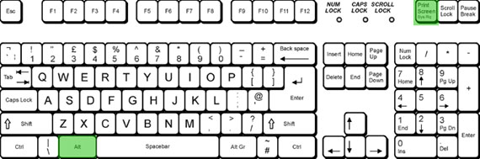

MAC
To copy your wedding map on a Mac hold down the Apple (Command) Key + Shift + 4
Your cursor will turn into a cross and you can hold down the mouse button and drag to select the part of the screen you want. Press 'Esc' to release.
When you release the button the screenshot will "snap" that part of the screen and create an image on your desktop. You can then import that image into your Wedding Map design.
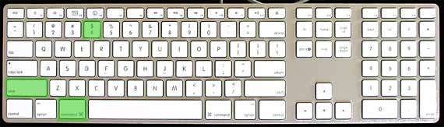

4. Paste into Microsoft Word

Create a new Word doc and set your paper size. To do this simply change the page size to the card dimensions (File, Page Setup, PAPER tab).

Paste your screenshot into the document by either hitting Ctrl + V or right clicking and selecting "Paste".

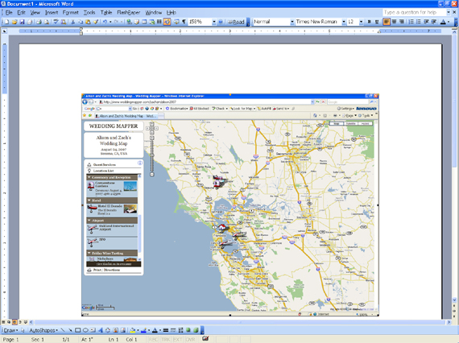

5. Crop and Enlarge Your Picture
Right click on the screenshot/map and click on "show picture toolbar". Then click on the "crop" icon in the toolbar.
Click on the box around the image and drag inward to crop the image to only show the important information. Once the image is cropped click on the "crop" icon again.
To enlarge your map click on the box around the image and drag outward.

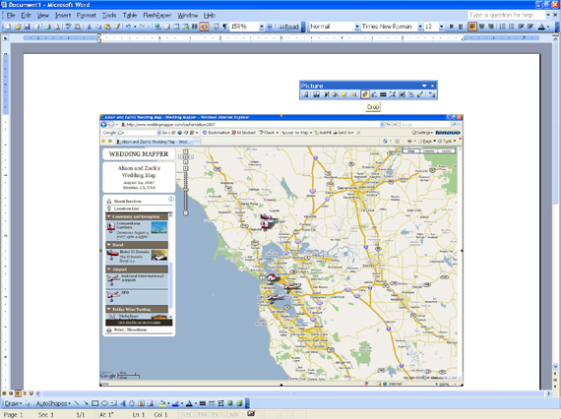

6. Create a Zoom Area
Go back to weddingmapper.com and zoom in on a specific area. Follow steps 1-5.

- Position the Zoom Area
To position the first map behind the second map, right click on the first map and click on “Format Picture”, “Layout”, and “Behind Text”. You can now move the first map behind the second map.

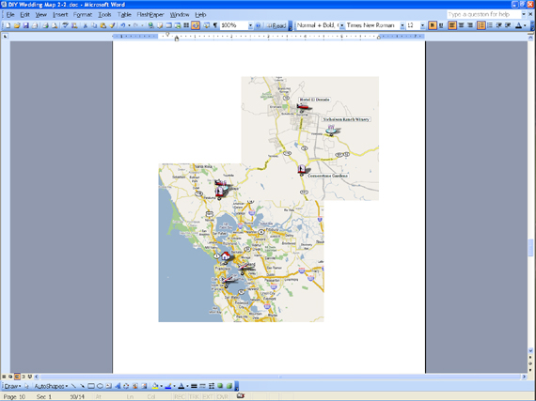

8. Create the Zoom Bubble
To add a circle around your map, go to “Insert”, “Picture”, and “AutoShapes”.
To make your shape transparent, right click on the shape, then “Format”, then “Color”, NO FILL.

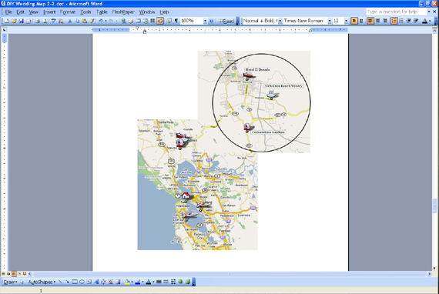

9. Connecting the Zoom Bubble
To insert a line, go to the Drawing Toolbar at the bottom of the document and click on Line. Draw a line between the first map and the second.

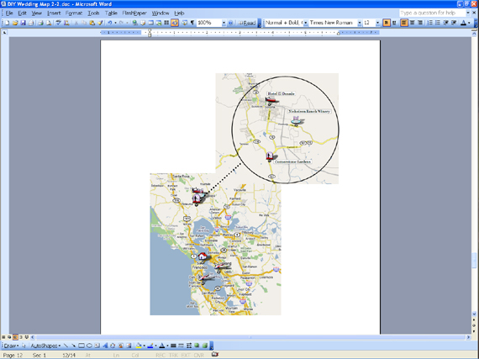

10. Finishing Touches
Add your title, addresses, a link to your WeddingMapper map, and you are done!

* Fun Tip – Play around with fonts, borders and colors to make your wedding map reflect the style of your wedding!
Zach and Alison
August 4, 2007
Sonoma, CA

Nicholson Ranch Winery Cornerstone Gardens Hotel El Dorado
4160 Napa Rd 23570 Arnold Dr 405 1st St W
Sonoma, CA 95476 Sonoma, CA 95476 Sonoma, CA 95476

Please visit our Wedding Map for more local attractions, information and directions: www.weddingmapper.com/zachandalison2007

PRINT
To print your map onto cardstock or paper directly from the Word document is simple but, you should practice a couple times to make sure things are lined up correctly.
Fun Ideas-
- Print out your maps on light colored cardstock or paper. Cut out your map/information and paste it onto a different colored piece of cardstock.
- Print out your maps in color, roll, and tie with the same color ribbon as your map font/border.
- Use your maps in invitations and in hotel welcome bags.

Directions

To get directions for your map go back to WeddingMapper.com and click on “Print/Directions”, “Get Directions”. You can get directions to or from any location on the map by selecting the location.
Simply click the location in the "Location List" or click the marker on the map.
In the bubble that pops up you can click to Get Directions "to here" or "from here".

- You can print out directions on the back of your map.

- Remember to tell your guests about your wedding map on WeddingMapper.com so that they can scope out your wedding area before the wedding. They can also print out their own directions to/from your favorite locations.

